TOCUS
Daily report



TOCUS DAILY REPORT
Summary for TOCUS Error! Bookmark not defined.

SUMMARY FOR TOCUS

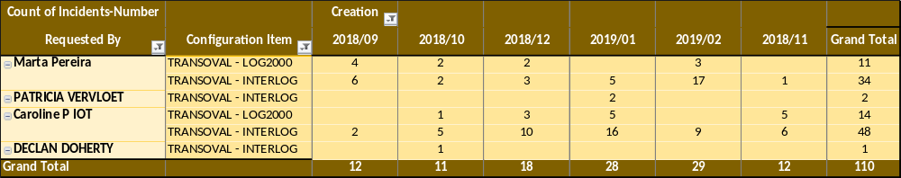SUMMARY FOR TOCUS

